**CA-1**

Question 1:

**CODE:**

package com.ca1;

import org.openqa.selenium.By;

import org.openqa.selenium.WebDriver;

import org.openqa.selenium.WebElement;

import org.openqa.selenium.chrome.ChromeDriver;

import org.openqa.selenium.chrome.ChromeOptions;

import io.github.bonigarcia.wdm.WebDriverManager;

public class TC_01 {

public static void main(String[] args) throws InterruptedException {

// TODO Auto-generated method stub

ChromeOptions co = new ChromeOptions();

co.addArguments("--remote-allow-origins=*");

WebDriverManager.*chromedriver*().setup();

WebDriver driver=new ChromeDriver();

driver.get("https://www.amazon.in/s?i=electronics&bbn=1805560031&rh=n%3A976419031%2Cn%3A1389401031%2Cn%3A1389432031%2Cn%3A1805560031%2Cp_36%3A1318505031%2Cp_n_condition-type%3A8609960031&ref_=tile1_below10k&pf_rd_r=JG6ACRFRGVMF1REN5FGN&pf_rd_p=6e9c5ebb-d370-421b-8375-bf50155e0300&pd_rd_r=e8601523-4a03-46c5-8db1-804b64da169b&pd_rd_w=CCN04&pd_rd_wg=TU7z0");

driver.manage().window().maximize();

driver.findElement(By.*xpath*("//*[@id=\"nav-link-accountList-nav-line-1\"]")).click();

driver.findElement(By.*xpath*("//*[@id=\"ap_email\"]")).sendKeys("6380270117");

driver.findElement(By.*id*("continue")).click();

driver.findElement(By.*xpath*("//*[@id=\"ap_password\"]")).sendKeys("vidhya");

driver.findElement(By.*id*("signInSubmit")).click();

Thread.*sleep*(20000);

driver.navigate().to("https://www.amazon.in/Timex-Analog-White-Womens-Watch-TW000X219/dp/B07QNXCKP6?ref_=Oct_DLandingS_D_285539a9_1");

String title = driver.getTitle();

String etitle="TIMEX Analog White Dial Women's Watch-TW000X219 : Amazon.in: Fashion";

System.*out*.println(title);

if(title.equals(etitle)) {

System.*out*.println("Title is matching");

}

else {

System.*out*.println("Title Mismatch");

}

driver.findElement(By.*xpath*("//*[@id=\"add-to-cart-button\"]")).click();

Thread.*sleep*(5000);

Boolean present = driver.findElement(By.*xpath*("//*[@id=\"attach-close_sideSheet-link\"]")).isDisplayed();

System.*out*.println("Is item added to cart:" + present);

driver.get("https://www.amazon.in/gp/cart/view.html/ref=dp_atch_dss_cart?");

Thread.*sleep*(5000);

driver.findElement(By.*xpath*("//*[@value=\"Delete\"]")).click();

Thread.*sleep*(2000);

String removeText = driver.findElement(By.*xpath*("//*[@id=\"sc-active-cart\"]/div/div[1]/div/h1")).getText();

String extext = "Your Amazon Cart is empty.";

if(removeText.equals(extext)) {

System.*out*.println("Product is removed");

}

driver.get("https://www.amazon.in/ASUS-15-6-inch-GeForce-Windows-FA506IHRZ-HN111W/dp/B0B5DZTNZQ?ref_=Oct_DLandingS_D_6c1a28b8_61");

driver.findElement(By.*xpath*("//*[@id=\"add-to-cart-button\"]")).click();

Thread.*sleep*(2000);

driver.get("https://www.amazon.in/gp/cart/view.html/ref=dp_atch_dss_cart?");

Thread.*sleep*(5000);

driver.findElement(By.*xpath*("//*[@id=\"a-autoid-0-announce\"]")).click();

driver.findElement(By.*xpath*("//*[@id=\"quantity_2\"]")).click();

Thread.*sleep*(2000);

driver.findElement(By.*xpath*("//*[@name=\"proceedToRetailCheckout\"] "));

Thread.*sleep*(1000);

String sign = driver.getTitle();

System.*out*.println(sign);

String esign = "Amazon Sign In";

if(sign.equals(esign)) {

System.*out*.println("Success");

}

else {

System.*out*.println("Failure");

}

}

}

**Output:**

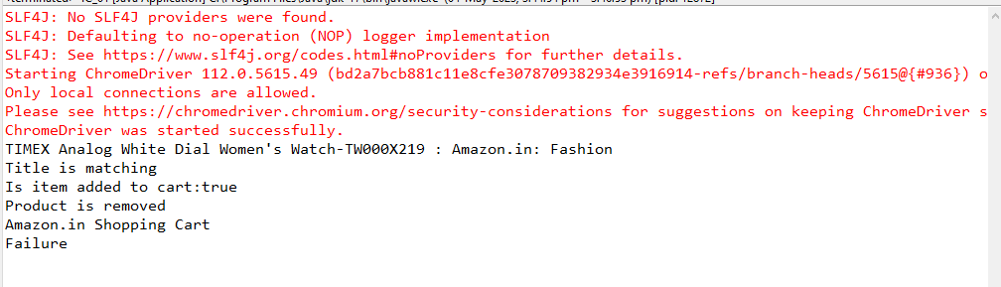

**Question 2:**

**CODE:**

package com.ca1;

import org.openqa.selenium.By;

import org.openqa.selenium.WebDriver;

import org.openqa.selenium.WebElement;

import org.openqa.selenium.chrome.ChromeDriver;

import org.openqa.selenium.chrome.ChromeOptions;

import io.github.bonigarcia.wdm.WebDriverManager;

public class TC_02 {

public static void main(String[] args) {

ChromeOptions co=new ChromeOptions();

co.addArguments ("--remote-allow-origins=*");

WebDriverManager.*chromedriver*().setup ();

WebDriver driver=new ChromeDriver(co);

driver.get ("https://www.amazon.in/");

driver.manage().window().maximize() ;

String currentTitle=driver.getTitle();

System.*out*.println(currentTitle);

String expectedTitle="Online Shopping site in India: Shop Online for Mobiles, Books, Watches, Shoes and More - Amazon.in";

if(currentTitle.equals(expectedTitle)) {

System.*out*.println("Title Matched");

}

else {

System.*out*.println("Title not Matched");

}

WebElement txtBoxl=driver.findElement(By.*xpath*("//*[@id=\"twotabsearchtextbox\"]"));

txtBoxl.sendKeys("watch");

driver.findElement(By.*xpath*("//*[@id=\"nav-search-submit-button\"]")).click();

String txt1=driver.findElement(By.*xpath*("//*[@id=\"search\"]/div[1]/div[1]/div/span[1]/div[1]/div[3]/div/div/div/div/div/div/div/div[2]/div/div/div[1]/h2/a/span")).getText();

System.*out*.println("TIMEX Analog Women's Watch (Dial Colored Strap)"));

String txt2=driver.findElement(By.*xpath*("//*[@id=\"search\"]/div[1]/div[1]/div/span[1]/div[1]/div[4]/div/div/div/div/div/div/div/div[2]/div/div/div[1]/h2/a/span")).getText();

System.*out*.println("Fossil Jacqueline Analog Silver Dial Women's Watch-ES5096");

String txt3=driver.findElement(By.*xpath*("//*[@id=\"search\"]/div[1]/div[1]/div/span[1]/div[1]/div[5]/div/div/div/div/div/div[2]/div/div/div[1]/h2/a/span")).getText();

System.*out*.println("Fossil Ring Watch Analog White Dial Women's Watch-ES5245");

String txt4=driver.findElement(By.*xpath*("//*[@id=\"search\"]/div[1]/div[1]/div/span[1]/div[1]/div[6]/div/div/div/div/div/div[2]/div/div/div[1]/h2/a/span")).getText();

System.*out*.println("Vibez by Lifelong Smartwatch for women Metal Strap & 1.28\" HD Display, Bluetooth Calling, Multiple Watch Faces, Health Tracker, Sports Modes & free silicone strap (Emerald, Gold)");

String txt5=driver.findElement(By.*xpath*("//*[@id=\"search\"]/div[1]/div[1]/div/span[1]/div[1]/div[7]/div/div/div/div/div/div[2]/div/div/div[1]/h2/a/span")).getText();

System.*out*.println("Titan Raga Viva Analog Rose Gold Dial Women's Watch-NL2608WM01");

//filter

driver.findElement(By.*xpath*("//*[@id=\"p_36/7252032031\"]/span/a/span")).click();

driver.findElement(By.*xpath*("//*[@id=\"p_n_pattern_browse-bin/1464446031\"]/span/a/span")).click();

}

}

**Output:**

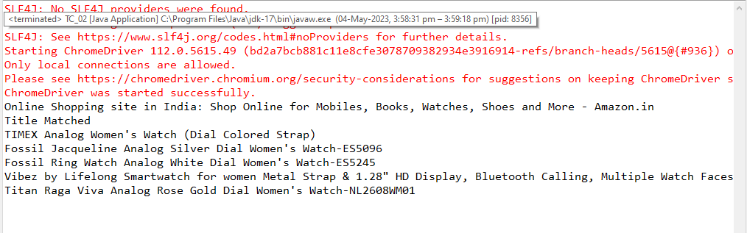

**Question 3:**

**CODE:**

package ca1;

import org.openqa.selenium.By;

import org.openqa.selenium.WebDriver;

import org.openqa.selenium.WebElement;

import org.openqa.selenium.chrome.ChromeDriver;

import org.openqa.selenium.chrome.ChromeOptions;

import io.github.bonigarcia.wdm.WebDriverManager;

public class ex3 {

public static void main(String[] args) {

ChromeOptions co=new ChromeOptions();

co.addArguments ("--remote-allow-origins=*");

WebDriverManager.chromedriver().setup ();

WebDriver driver=new ChromeDriver(co);

driver.get ("https://www.amazon.in/");

driver.manage().window().maximize() ;

String currentTitle=driver.getTitle();

System.out.println(currentTitle);

String expectedTitle="Online Shopping site in India: Shop Online for Mobiles, Books, Watches, Shoes and More - Amazon.in";

if(currentTitle.equals(expectedTitle)) {

System.out.println("Title Matched");

}

else {

System.out.println("Title not Matched");

}

driver.findElement(By.xpath("//*[@id=\"nav-link-accountList\"]")).click();

WebElement txtBoxl=driver.findElement(By.xpath("//*[@id=\"ap_email\"]"));

txtBoxl.sendKeys("6380270117");

driver.findElement(By.xpath("//*[@id=\"continue\"]")).click();

WebElement txtBox2=driver.findElement(By.xpath("//*[@id=\"ap_password\"]"));

txtBox2.sendKeys("vidhya");

driver.findElement(By.xpath("//*[@id=\"signInSubmit\"]")).click();

// driver.findElement(By.xpath("//*[@id=\"nav-link-accountList\"]")).click();

// driver.findElement(By.xpath("//*[@id=\"a-page\"]/div[2]/div/div[2]/div[1]/a/div/div")).click();

// driver.findElement(By.xpath("//*[@id=\"a-autoid-2-announce\"]")).click();

// driver.findElement(By.xpath("//*[@id=\"ordersInPackage-container\"]/div/div/a[1]")).click();

}

**Output:**

